

**Script Runner User Guide**

Prepared

By

Milyli Inc. (Milyli)

11/12/2017

Table of Contents

1.0 Script Runner Overview 2

2.0 Installing the Script Runner Application 2

3.0 Using the Script Runner Application 4

4.0 Scheduling a Job with the Script Runner 6

5.0 Script Job History 8

# Script Runner Overview

The script runner allows Relativity administrators to schedule scripts that can be ran once or multiple times. An admin can also execute a script manually from within the application.

Admins can create new scheduled script jobs, edit existing jobs, and view the list of scheduled jobs.

# 2.0 Installing the Script Runner Application

**NOTE: The script runner application must be installed within a workspace for the workspace to show up in the tools workspace list**

**Installing the application**

1. Click the **Application Library** tab.
2. Click **Upload Application**.
3. Click **Choose file** to select an application file.
4. Select the following rap **ScriptRunner.rap**
5. Click **Open**, and then click **Save** to upload the file to the Application Library. The application appears on the list page.
6. Click **Install** in the Workspaces Installed section to install the application on workspaces.
7. Click ellipsis button in the Workspaces field to display the Select Workspaces dialog.
8. Select the workspaces where you want to install the application, and then click **Ok**.
9. (Optional) Click **Clear** to remove a workspace from the list.
10. Click **Save** to install the application to the selected workspaces. These workspaces now contain the application. Relativity lists the workspaces in the Workspaces Installed section on the detail view of the application.

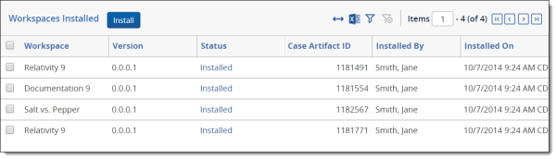

**Setting up the agent**

1. From **Home**, select the **Agents** tab.
2. Click **New Agent**. The Agent Information screen displays.
3. Complete all of the fields in the Agent Information section. See [Fields](https://help.relativity.com/9.5/Content/System_Guides/Agents_Guide/Adding_and_editing_agents.htm#Fields) for details.
   1. Select Agent type of **Milyli ScriptRunner Agent**
4. From the **Enabled** field, select **Yes** to enable the agent or **No** to create the agent without enabling it on the server.
5. Click **Save**. If the agents were successfully added to the environment, you'll see a green check box and message at the top of the page.

**NOTE: The script runner application is a single threaded agent application. Duplicate agents will pick up and process the same jobs at the same time.**

More information about installing applications and creating agents is available from the main Relativity documentation site:

https://help.relativity.com/9.5/Content/Relativity/Applications/Installing_applications.htm

https://help.relativity.com/9.5/Content/System_Guides/Agents_Guide/Adding_and_editing_agents.htm

# 3.0 Using the Script Runner Application

Once installed, the application creates a Milyli ScriptRunner tab:



1. Select the **ScriptRunner** tab
2. By default, you will view the Admin Workspace in the Relativity Script Library
3. Filter the group to view only the scripts available to a particular workspace by entering the workspace name in the **Current Workspace** field:
   1. This field has a type ahead feature built in  
        
      

**NOTE: While the script you want to schedule may be visible in the Admin Workspace, you must filter the list of scripts to reflect the specific workspace for which you want to run the script. This ensures that the data required by any Script Input fields is available.**

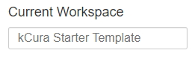

1. Once the desired workspace has been added you will see the **Relativity Script List** display which has a list of all scripts available in the workspace
2. The **Relativity Script List** table displays the following information:
   1. **Script Name**
   2. **Schedule Count** (shows how many jobs have been created for the script by the Script Runner application)
   3. **Last Execution Time** (last time the script was run)
      1. NOTE: If none is displayed that the scheduled job has never run with the application
      2. NOTE: The “**Last Execution Time**” field will display the most recent run time of the script, whether the script was run automatically by the Script Runner or executed manually.
   4. **Next Execution Time** (the next time the script will be run)
      1. NOTE: If none is displayed that the scheduled jobs are not enabled and will not run in the future
3. To schedule a new job with the Script Runner, select the **plus sign(+)** to the right of the script you want to add a scheduled job to:



# 4.0 Scheduling a Job with the Script Runner

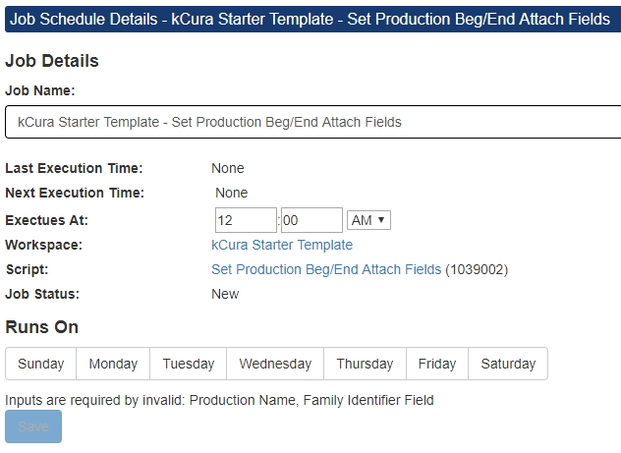

*Disabled saved button*

**Job Setup**

1. Complete all of the fields in the Agent Information section.
   1. **Job Name**
      1. Manually added by the user. This is a descriptive name to identify the Script Runner job.
   2. **Last / Next Execution Time**
      1. Displays the last time the script was executed by the application.
   3. **Executes At**
      1. Displays the next time the script is scheduled to be executed by the application.
      2. The script will be executed at the selected time in the time zone of the server, not the local time zone of the user (which may be different than the time zone of the server).
   4. **Workspace**
      1. Displays the workspace that the script is associated to. This is set by the application.
   5. **Script**
      1. Displays the script name that the scheduled job is associated to. This is set by the application.
   6. **Job Status**
      1. Displays the current job status
         1. While creating a new job the status will be **New**
         2. When the job is created and saved is will show **Idle** and include two buttons **Run** and **Disable** as shown below:



* + - 1. If the time the job is set to execute has elapsed, but the agent has not yet picked up the script for execution the status will be **Waiting for Agent**
  1. **Runs On**
     1. Allows the user to select one or multiple days for the script to run by just selecting the day button.

**Script Inputs**

**NOTE: If there are required fields the save button will not be enabled until all required fields for the script have been filled in.**

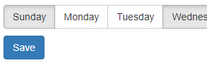

*Enabled saved button*

1. Script Input fields are visible on the right side of the Job Schedule Details page
   1. Complete all of the fields in the Agent Information section.

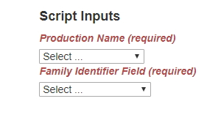

*Required script inputs incomplete*

If you don’t see any data in the Script Input dropdown lists:

* No data exists in the workspace for a given field. For example, the field may require a Production Name, but no productions exist yet. In this case, it will not be possible to schedule a script with the Script Runner until all the required data is available.

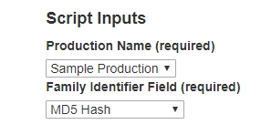

*Required script inputs completed*

# 5.0 Script Job History

The Relativity Script List provides a link to the jobs and history of every script processed through the application. This can be accessed by clicking on the script name.

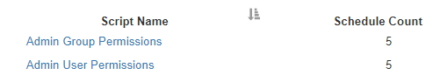

Once you have clicked into a script, the Job History is only available for scripts that have run at least once, whether automatically scheduled by the Script Runner or run manually.

1. Select the job name to see the full history
2. The Job History is found at the bottom of the job details page.
3. Each entry is added by the date/time of the job execution.
4. Details can be found by expanding the results count on or by using the paging controls. These controls are in the upper left portion of the table and look like this:



1. The **Job History** table displays the following information:
   1. **Start time**
      1. System set time of actual script execution
   2. **Running Time, Seconds**
      1. System set duration of the script execution
   3. **Results**
      1. System message from the execution of the script
         1. This will show **Success** if the job did not encounter an error.
         2. If an error was encountered, the error from the script will be displayed here.

